1. **Mini-assignment – Kalman filter**

Design a Kalman filter to track the following measurement points.



Note that MeasGT.csv: It has the following 5 columns:

    time (in second),  measured x (m), measured y (m), ground truth x (m), ground truth y (m)

The target is moving in Constant Velocity with speed 12.5m/s, measurement error stvd is 10m for both x and y.

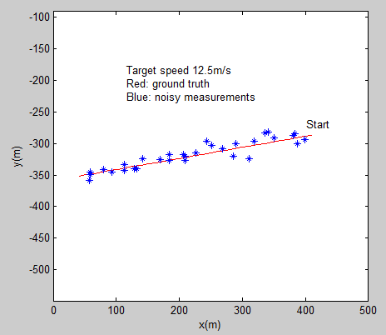

Submission date by end of week 3.